MTH 200 | Derivatives

Directions: Solve all problems on a separate sheet(s) of paper. Place your name on the pages you submit. You must show all of your work to receive full credit on problems. You must write complete sentences when asked to show/prove something or provide an explanation/justification. You are encouraged to work with others, consult sources, use calculators, etc. However, only submit solutions that you fully understand. Do not submit solutions which are copied from a friend or another source.

Challenge Questions

Derivatives
- Give an example where and are increasing at but is decreasing at .

- Show that the function (graph shown below) is differentiable at . Hint: You need to use the definition of the derivative.

We know that in order for a function to be differentiable at it must be the case that exists, that is it must be true that the limit exists.

Since we want to show that is differentiable at we must show that exists.

We see that .

We note that for any non-zero value of h that . Then,
if and
if and

In either case we still have that which implies, by the Squeeze Theorem, that . Therefore, we have showed that and thus exists. So, is differentiable at .

Calculate derivatives

Note that
Therefore,

- Compute the second derivative for the function .

- The following graph depicts the position of two racers.
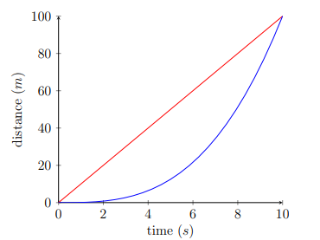
- Which racer has a faster average speed? When was each racer running faster than the other (approximately)? Which racer was running fastest at the end of the race?
- On a separate plot from this picture, sketch the graphs of the velocities of these racers.
- Suppose that the distance (from the starting point) of the red racer is given by the function and the distance of the blue racer is given by . When you have completed parts (a) and (b), ask me for these functions. Use this new information (and your knowledge of derivatives) to check whether your answers in parts (a) and (b) were accurate.

- Let . Find values of m and b that make f differentiable everywhere.

We know that in order for a function to be differentiable at it must be the case that exists, that is it must be true that the limit exists.

Since we want to show that is differentiable at we must show that exists.

We see that .

We then check the limit from both sides.

The second limit can’t be finished yet, but we note that since the limit from the left equals 4 we also need the limit from the right to equal 4 in order for the limit to exist and thus have be differentiable everywhere.

If we let and , then and thus which implies that is differentiable at .

So, is differentiable everywhere.

- Consider the polynomial functions , , and , where represent real numbers.
- Find , , and .
- If n represents the degree of the polynomial, then what is the -st derivative of any polynomial? Why?

- The function f has the property that and the tangent line to its graph at passes through the point . What is ?

- If a tank holds 500 gallons of water, which drains from the bottom of the tank in 40 minutes, then Torricelli’s Law gives the volume V of water remaining in the take after t minutes as
- At what rate is the water draining from the taken after 10 minutes?

We calculate
.

- When is the water flowing out the fastest?
- When is the water flowing out the slowest?

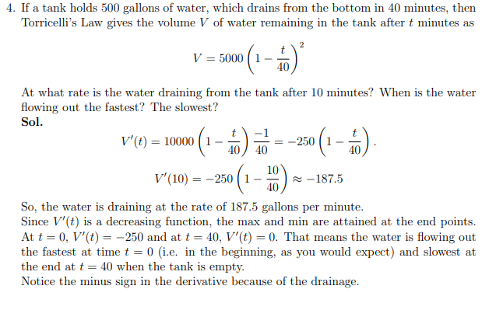

- A 30ft deep retention pond is roughly shaped like a section of an inverted right circular cone, the bottom having a radius of 250ft and the top having a radius of 300ft (see the diagram below). During a heavy rainstorm, the pond has overcome its discharge tube and has risen to 24ft deep. At that instant the water level is still rising at the rate of about 2inches/hour. If the rain doesn’t let up, when would you predict the pond to overflow its banks?
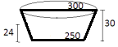

We see the

